ExNo:14 <!--UNORDER LIST-->

PROGRAM:

<html>

<body>

<p><b>MY FAMILY</b></p>

<ul>

<li>DINESH</li>

<li>SANTHOSH</li>

<li>MURUGAN</li>

<ul>

<li>DINESH</li>

<li>SANTHOSH</li>

<li>MURUGAN</li>

</ul>

<li>DINESH</li>

<li>SANTHOSH</li>

<li>MURUGAN</li>

</ul>

</body>

</html>

OUTPUT:

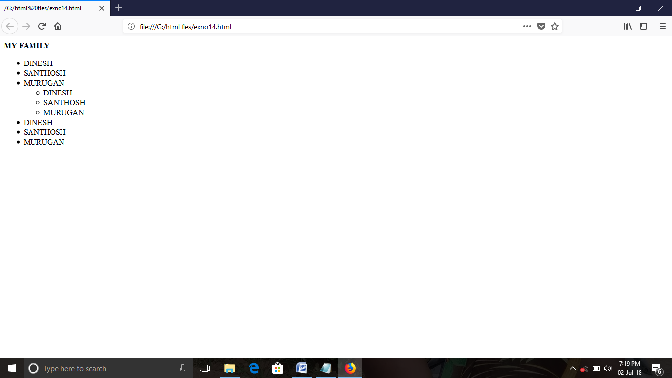

ExNo:15 <!--ORDER LIST-->

PROGRAM:

<html>

<body>

<p><b>MY FAMILY</b></p>

<ol>

<li>DINESH</li>

<li>SANTHOSH</li>

<li>MURUGAN</li>

<ol>

<li>DINESH</li>

<li>SANTHOSH</li>

<li>MURUGAN</li>

</ol>

</ol>

</body>

</html>

OUTPUT:

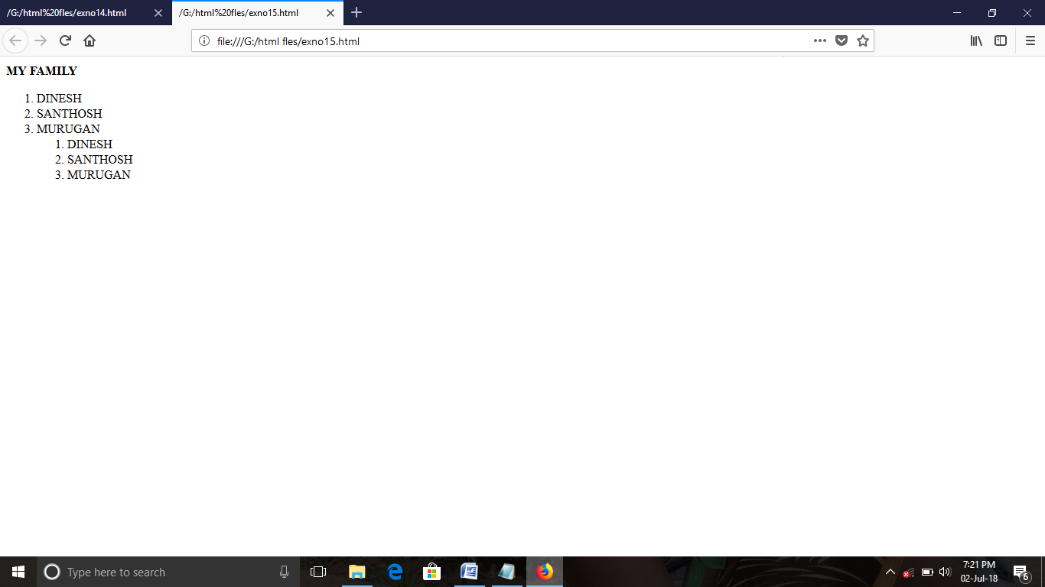

ExNo:16 <!--DEFINITION LIST-->

PROGRAM:

<html>

<title>

definition list

</title>

<body>

<dl>

<dt>NAMES</dt>

<dd>PARAMSHWARI</dd>

<dd>MURUGAN</dd>

</dl>

</body>

</html>

OUTPUT:

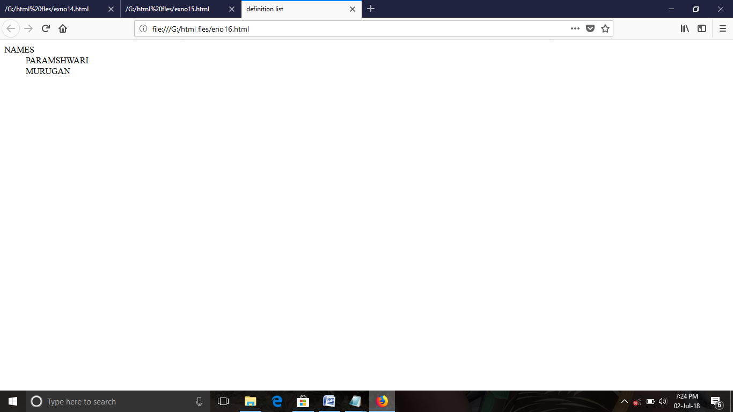

ExNo:17 <!--BASIC TABLE-->

PROGRAM:

<html>

<title>

table

</title>

<body>

<table border="2">

<tr>

<th>name</th>

<th>class</th>

</tr>

<tr>

<td>dinesh</td>

<td>3rd year</td>

</th>

</tr>

</table>

</body>

</html>

OUTPUT:

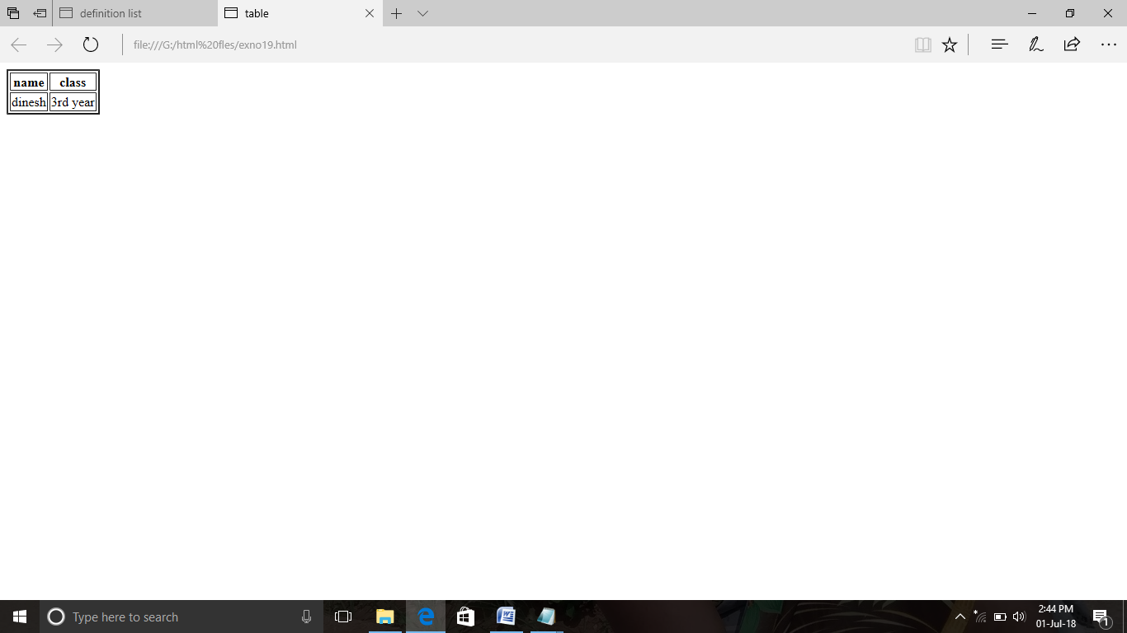

ExNo:18 <!--TABLE WITH COLOR-->

PROGRAM:

<html>

<title>

table

</title>

<body>

<table border="1" bgcolor="red">

<tr>

<td>name</td>

<td>mark</td>

</tr>

<tr>

<td>dinesh</td>

<td>120</td>

</tr>

<td>karthi</td>

<td>235</td>

</tr>

</table>

</body>

</html>

OUTPUT:

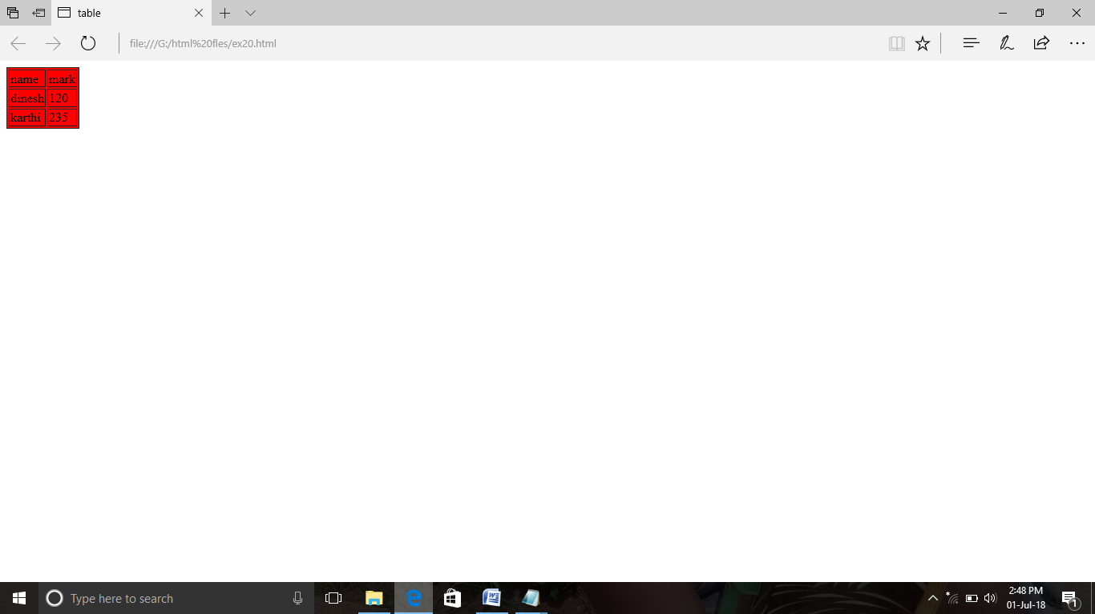

ExNo:19 <!--TABLE WITH SPANNING-->

PROGRAM:

<html>

<title>

span

</title>

<body>

<p><b>WEB TECHNOLOGY</b></p>

<table border="1">

<tr>

<th rowspan="2" colspan="">

<th>name</th>

<th>mark</th>

</tr>

<td>MURUGAN</td>

<td>00</td>

<td>458</td>

</th>

</table>

</body>

</html>

OUTPUT:

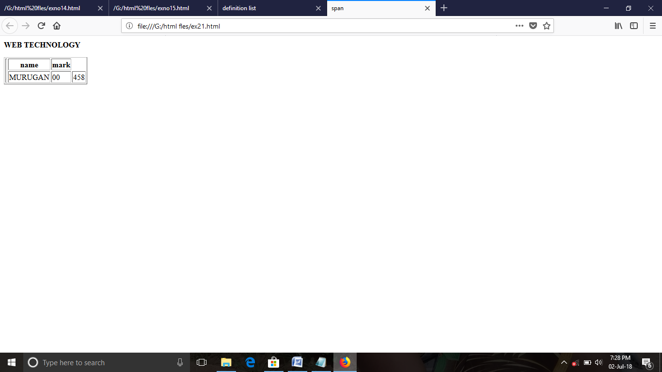

ExNo:20 <!--BGCOLOR-->

PROGRAM:

<html>

<title>

bgcolor

</title>

<body bgcolor="pink">

<p><b>i"m learning html</b></p>

</body>

</html>

OUTPUT:

